Name ______________________________________________________________

Navigate with ultrasound:
Go to : https://learn.parallax.com/tutorials/robot/activitybot/blocklyprop-robotics-activitybot/navigate-ultrasound
Follow the directions for building and testing the sensor.When you get to the point in the instructions that you see the following image?
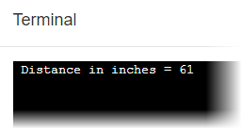show the teacher that it is working and have the teacher initial on this line ___________________________________________________
Continue along until you have it making a tone which varies depending upon your distance from an obstruction and have the teacher initial on this line __________________________

Go to https://learn.parallax.com/tutorials/robot/activitybot/blocklyprop-robotics-activitybot/navigate-ultrasound/roaming-ultrasound
Follow the directions and continue to where it tells you to build a maze out of boards or boxes…
Do that, and make your robot navigate through the maze.
Demonstrate to the instructor. ______________________________________________

